**DAILY ONLINE ACTIVITIES SUMMARY**

|  |  |  |  |  |  |  |  |  |
| --- | --- | --- | --- | --- | --- | --- | --- | --- |
| **Date:** | **30-06-2020** | | | | | **Name:** | **Anix Jugal D’Cunha** | |
| **Sem & Sec** | **8 sem , A sec** | | | | | **USN:** | **4AL16CS013** | |
| **Online Test Summary** | | | | | | | | |
| **Subject** | | **Test was not conducted Today** | | | | | | |
| **Max. Marks** | | **--** | | **Score** | | | **--** | |
| **Certification Course Summary** | | | | | | | | |
| **Course** | **Learn SQL From Scratch** | | | | | | | |
| **Certificate Provider** | | | **Udemy** | | **Duration** | | | 1.5 hours |
| **Coding Challenges** | | | | | | | | |
| **Problem Statement:** 1) Python code to demonstrate a dictionary with multiple inputs in a key.  2) Write a C Program to generate first n Ugly Numbers | | | | | | | | |
| **Status: Competed** | | | | | | | | |
| **Uploaded the report in Github** | | | | | **yes** | | | |
| **If yes Repository name** | | | | | **alvas-education-foundation/dcunhaanixjugal** | | | |
| **Uploaded the report in slack** | | | | | **yes** | | | |

Online Test Details: (Attach the snapshot and briefly write the report for the same)

**Test was not conducted Today**

Certification Course Details: (Attach the snapshot and briefly write the report for the same)

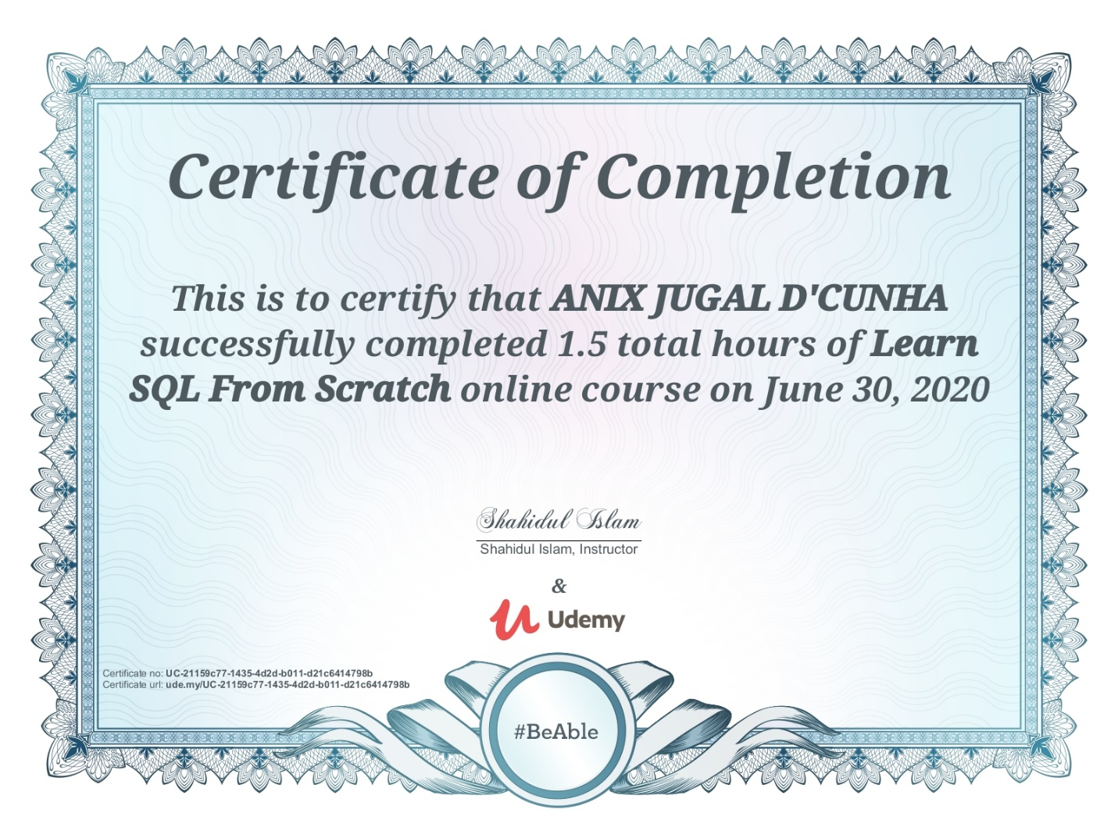

Coding Challenges Details: (Attach the snapshot and briefly write the report for the same)

## Program->

## Python code to demonstrate a dictionary with multiple inputs in a key.

|  |
| --- |
|  |
|  |  |
|  | import random as rn |
|  |  |
|  | # creating an empty dictionary |
|  | dict = {} |
|  |  |
|  | # Insert first triplet in dictionary |
|  | x, y, z = 10, 20, 30 |
|  | dict[x, y, z] = x + y - z; |
|  |  |
|  | # Insert second triplet in dictionary |
|  | x, y, z = 5, 2, 4 |
|  | dict[x, y, z] = x + y - z; |
|  |  |
|  | # print the dictionary |
|  | print(dict) |

## Write a C Program to generate first n Ugly Numbers

|  |
| --- |
|  |
|  |  |
|  |  |
|  |  |
|  | # include<stdio.h> |
|  | # include<stdlib.h> |
|  |  |
|  | /*This function divides a by greatest divisible |
|  | power of b*/ |
|  | int maxDivide(int a, int b) |
|  | { |
|  | while (a%b == 0) |
|  | a = a/b; |
|  | return a; |
|  | } |
|  |  |
|  | /* Function to check if a number is ugly or not */ |
|  | int isUgly(int no) |
|  | { |
|  | no = maxDivide(no, 2); |
|  | no = maxDivide(no, 3); |
|  | no = maxDivide(no, 5); |
|  |  |
|  | return (no == 1)? 1 : 0; |
|  | } |
|  |  |
|  | /* Function to get the nth ugly number*/ |
|  | int getNthUglyNo(int n) |
|  | { |
|  | int i = 1; |
|  | int count = 1; /* ugly number count */ |
|  |  |
|  | /*Check for all integers untill ugly count |
|  | becomes n*/ |
|  | while (n > count) |
|  | { |
|  | i++; |
|  | if (isUgly(i)) |
|  | count++; |
|  | } |
|  | return i; |
|  | } |
|  |  |
|  | /* Driver program to test above functions */ |
|  | int main() |
|  | { |
|  | unsigned no = getNthUglyNo(150); |
|  | printf("150th ugly no. is %d ", no); |
|  | getchar(); |
|  | return 0; |
|  | } |